*Margie’s Travel Presents…* **San Francisco**

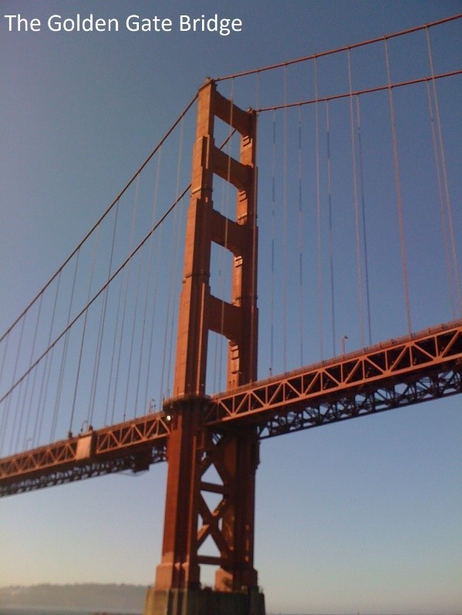San Francisco, officially the City and County of San Francisco, is the cultural, commercial, and financial center of Northern California. It is the birthplace of the United Nations. Located at the north end of the San Francisco Peninsula, San Francisco is about 47.9 square miles in area, making it the smallest county—and the only consolidated city-county— within the state of California. With a density of about 18,581 people per square mile, San Francisco is the most densely settled large city in California and the second-most densely populated major city in the

United States after New York City. San Francisco is the fourth-most populous city in California, after Los Angeles, San Diego, and San Jose, and the 13thmost populous city in the United States—with a census-estimated 2016 population of 870,887. The city and its surrounding areas are known as the San Francisco Bay Area, and are a part of the larger

OMB-designated San Jose-San Francisco-Oakland combined statistical area, the fifth most populous in the nation with an estimated population of 8.7 million.

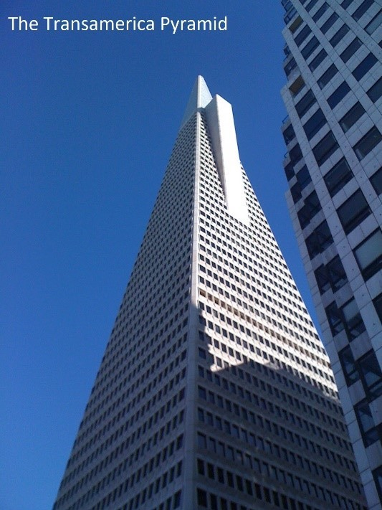

**San Francisco Hotels**

Margie’s Travel offers the following accommodation options in San Francisco:

**The Lombard Hotel**

Friendly, family-run hotel within easy walking distance to popular sights, including the Golden Gate Bridge and the Presidio. Free Parking.

**The Wharf Hotel**

Great value accommodation in the heart of the vibrant Fisherman’s Wharf area. Continental Breakfast included.

# To book your trip to San Francisco, visit www.margiestravel.com